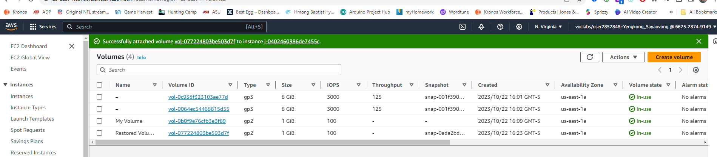

Building an environment in Amazon Web Services (AWS) proves to be an economically savvy alternative compared to traditional infrastructure, chiefly because of AWS's innovative pay-as-you-go pricing approach. This approach obliterates the need for committing to long-term contracts and incurring termination fees, rendering it an efficient choice for businesses. By embracing this pay-as-you-go model, organizations exclusively pay for the services they actively employ, thereby circumventing downtime charges and optimizing their workspace utilization, ultimately contributing to enhanced profits.

In sharp contrast to conventional infrastructures, AWS effectively removes the requirement to procure additional servers and server space. This traditional approach often results in depreciating assets over time, leading to unneeded expenditures for businesses as they expand. AWS, on the other hand, allows businesses to scale their infrastructure with ease, only paying for the resources they consume. As a result, AWS proves to be a more cost-effective choice, especially for organizations in growth mode.

Furthermore, constructing an environment within Amazon Cloud Web Services positively influences product quality. This stems from the fact that it facilitates quicker decision-making by outsourcing crucial IT responsibilities, such as maintenance, labor, security, and backups. By delegating these operational tasks to AWS, businesses can reallocate their internal resources towards vital areas like the development of new products and quality assurance, which in turn bolsters their competitive edge.

When discussing the financial implications of adopting AWS over traditional infrastructures, the concept of Total Cost of Ownership (TCO) comes into play. TCO encompasses both asset and operational costs. In the case of traditional infrastructures, TCO calculations must take into account ongoing maintenance expenses, potential equipment downtime, and the ever-present costs associated with updating outdated software and equipment. By opting for AWS, these concerns are significantly alleviated, as AWS assumes responsibility for the infrastructure's robustness and modernity, leaving organizations free to focus on their core competencies.

In addition to cost savings, AWS also delivers a host of other advantages. One key benefit is the boost to real estate earnings, as organizations can downsize or eliminate their on-premises data centers. Moreover, AWS's infrastructure is designed to be energy-efficient, reducing overall energy consumption and costs, which would otherwise be a significant burden for on-premises operations. Another noteworthy cost reduction comes from eliminating labor and training expenses. With AWS, fewer IT staff are required, as many of the operational tasks are automated, and AWS's comprehensive training programs help organizations upskill their workforce for efficient cloud management. This streamlined workforce contributes to scalability and reliability, offering businesses peace of mind as they navigate their growth trajectory.

In summary, building an environment in Amazon Web Services offers numerous economic and operational advantages over traditional infrastructure. Its pay-as-you-go pricing model, resource scalability, and the outsourcing of critical IT functions empower organizations to optimize their financial performance and product quality. When calculating the Total Cost of Ownership, AWS emerges as a cost-effective alternative, sparing businesses from the burdens of maintenance, downtime, and constant software and hardware updates. Furthermore, AWS leverages its technological prowess to reduce real estate and energy costs, while also simplifying workforce management. All of these factors collectively establish AWS as a compelling choice for businesses aiming to maximize their operational efficiency and profitability.

**Table 1**

Amazon Web Services 1 year cost

|  |  |  |
| --- | --- | --- |
| Server Type | Quantity | Total Cost (12 Months) |
| Server Farm 1 | 8 | 5250.00 |
| Server Farm 2 | 12 | 8681.40 |
|  |  | 13,931.40 |

**Table 2**

Dell Enterprise 1 year cost

|  |  |  |
| --- | --- | --- |
| Server Type | Quantity | Total Cost (12 Months) |
| Server Farm 1 | 8 | 14,726.04 |
| Server Farm 2 | 12 | 19,138.73 |
|  |  | 33,864.77 |

**Table 3**

Total cost AWS and Dell Infrastructure

|  |  |  |
| --- | --- | --- |
| Server Type | Option | Total Cost (12 Months) |
| Server Farm 1 | AWS | 5250.00 |
| Server Farm 1 | Dell | 14,726.04 |
| Server Farm 2 | AWS | 8681.40 |
| Server Farm 2 | Dell | 19,138.73 |

**References:**

Burkhalter, M. (2021, May 4). The cost savings of cloud computing. Retrieved from www.perle.com website: <https://www.perle.com/articles/the-cost-savings-of-cloud-computing-40191237.shtml>

Hamus, C. (n.d.). Counting the Cost of Manufacturing in the Cloud. Retrieved October 22, 2023, from www.vertech.com website: <https://www.vertech.com/blog/cost-of-manufacturing-in-the-cloud>

LeadingEdge. (2019). LeadingEdge IT Services & Solutions. Retrieved from LeadingEdge IT Services & Solutions website: <https://www.leadingedgetech.co.uk/it-services/it-consultancy-services/cloud-computing/how-is-cloud-computing-different-from-traditional-it-infrastructure/>

Twin, A. (2021, October 30). Total Cost of Ownership (TCO): Asset Costs Over the Long Term. Retrieved from Investopedia website: <https://www.investopedia.com/terms/t/totalcostofownership.asp>